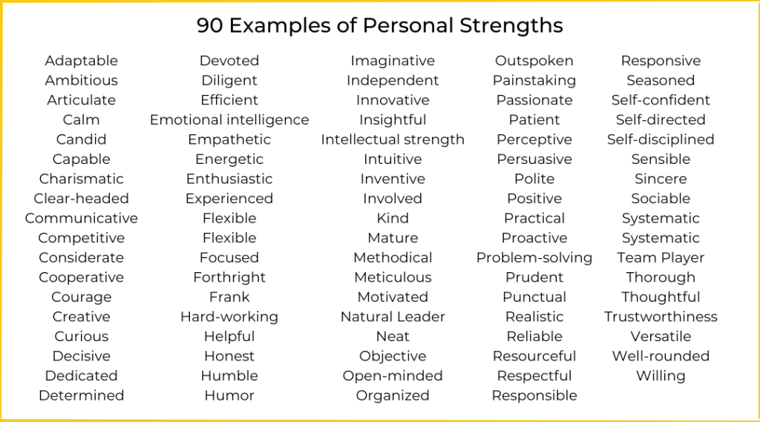Consider your experience, knowledge, skills, and talents in both your personal and your work life – what do you enjoy doing? Work through the list of strengths below ticking those which you think apply to you – try to find an example of where you use the strengths you’ve identified in your life.